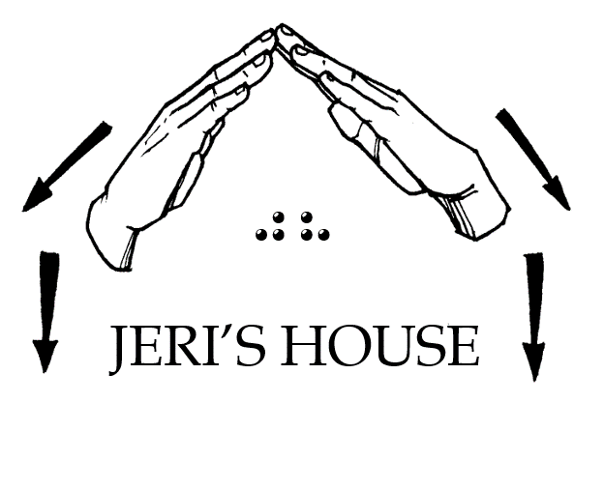
Jeri’s House, Inc.
P.O. Box 14192, Tulsa, OK 74159
Tel: (918) 200-6550 Web: www.jerishouse.org

STAFF APPLICATION

TO SERVE AT JERI'S HOUSE

Jeri Cooper's in-depth experience in the rehabilitation of DeafBlind individuals, her professional connections in the DeafBlind community, and leadership skills serve as the cornerstone and driving force of this organization.

Jeri's House is a Bible-based 501©3 ministry. It has been organized to provide a safe place for individuals who are DeafBlind to transition to independent living, to promote and encourage self-esteem and self-confidence by creating a social, economic, and cultural transformation toward long-term sustainability. Individuals will now be able to contribute to their community and become an asset in society.

Staff shall be sought who have experience or working interest in areas such as teaching, knowledge of DeafBlind, Support Service Provider (SSP), interacting with individuals who are DeafBlind, possess a knowledge of Sign Language, leisure and recreational skills, and/or possess a specific skill necessary to assist the individual who is DeafBlind reach their goal of independent living.

PERSONAL INFORMATION

FULL NAME:

STREET ADDRESS:

PHONE NUMBER:

EMAIL ADDRESS:

DATE OF BIRTH:

GENDER:

SOCIAL SECURITY NUMBER:

WILL YOU VOLUNTARILY SUBMIT TO A BACKGROUND CHECK?
---YES ---NO

SIGNATURE:

DATE:

EXPERIENCE

Have you worked with individuals who are DeafBlind? If yes, explain:

Are you a certified SSP?

Are you a certified interpreter?

Do you know ASL?

Do you know the manual alphabet?

Do you know proper sighted guide techniques?

SIGNATURE:

DATE:

PERSONAL REFERENCES

NAME:

PHONE:

EMAIL:

NAME:

PHONE:

EMAIL:

